**Hyperparamter**

N_neig

**Uniform:** yeah vote jaisa hota hai kindoff E.g Votes ke mamle mai koi bada chota nahi hota lyk koi value nahi hoti

Elon Musk ka vote bhi 1 Vote hai , Mera Vote bhi 1 vote hai Lyk that

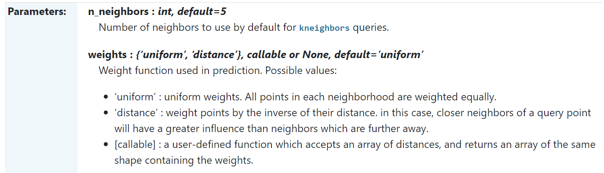

***Weighted KNN***

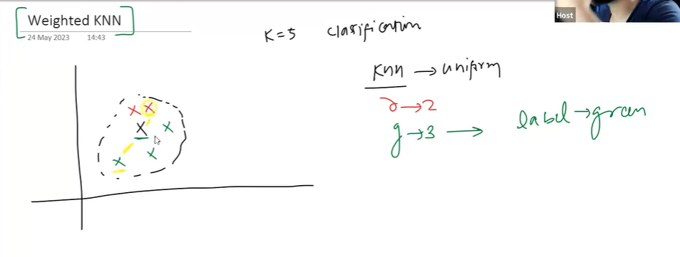

Black is query point

Red & green point neighbourhood hai uske

Agar simple Uniform lagate then Hum simple count karte

Red kitne hai & Green Kitne hai

& Majority count lagate & bolte Green Majority Count mai jeetgaya

So Query Point ka label hai Green.

Weigted KNN mai hum yeah logic lagate hai ki

Jo Point ya neighbour zyaada close hai uska Weightage zyaada hona chaye.

Weightage dene ke alag alag tarike hai but sbhse Simple tarika yeah hai ki

1 Simple tarika hai jishse har point ka weight calculate krte hai lyk this.

**W = 1 / distance**

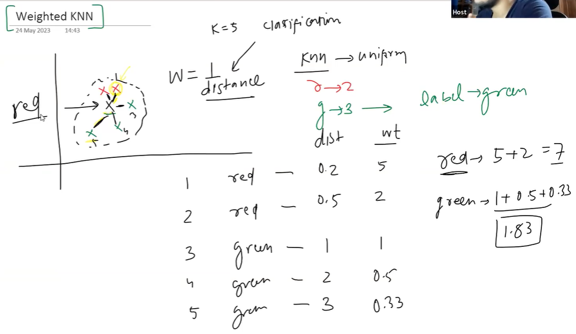

**This is how Weighted KNN works, agar Normal KNN rehta tou Sidhe Green boldeta**

**So ese hum weights change karskte , Default mai Uniform set rehta**

**Weighted will most likely work good with Outliers.**

***Types of Distances***

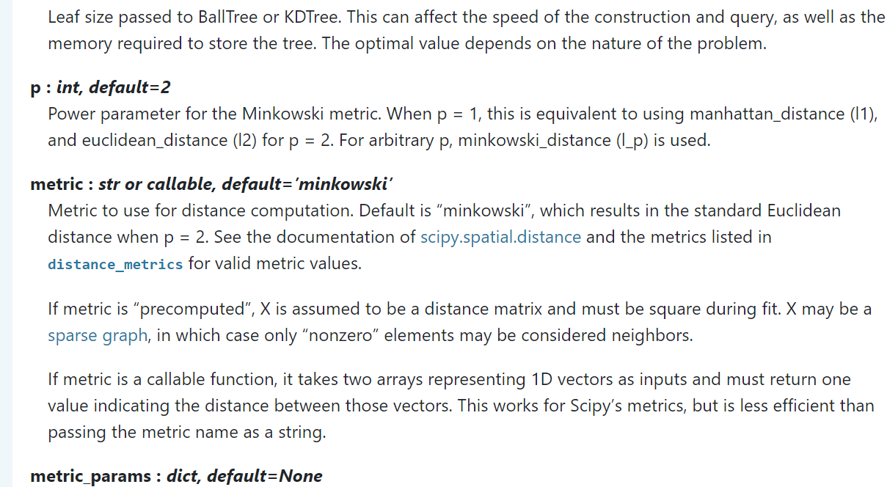

**P ka value change krskte hai ushse distance ka technique change hoga**

**Default mai Euclidean_distance follow krta hai yeah**

***Eucledian Distance***

2 points ke beech ka shortest distance

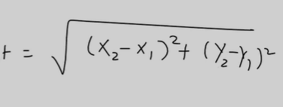

Good Part abt this is Hum kitne bhi dimension mai eucledian distance nikalskte hai

*Manhattan Distance*

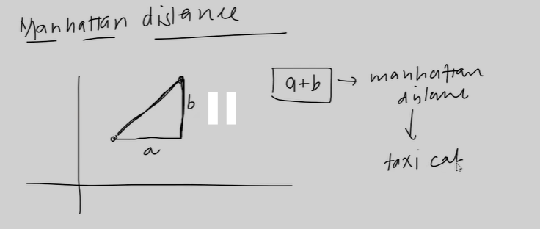

***Formula:***

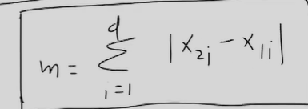

**Problems of Euclidean**

1. **Every axis must be of Same Scale.**
2. **Curse of Dimensionality**

**Zyaada Dimension mai prblm aata hai Euclidean Distance.**

**Agar Scale Same nahi hai at that time We can use Manhattan distance.**

**So p =1 krdenge tou Manhattan &**

**P = 2 kardenge tou Euclidean Distance.**

**What is Minkowski ?**

Yeah Umbrella term hai jiske andar types of distance rehte hum bss p ka value set krte yaha

* **L2 Norm -> Euclidean**
* **L1 Norm -> Manhattan**

**As per 1 Research paper**

**Higher Dimension Data ke liye Manhattan is better than Euclidean Distance.**

